**National University of Computer & Emerging Sciences, Karachi**

**Computer Science Department**

**Fall 2022, Lab Manual - 04**

|  |  |
| --- | --- |
| **Course Code: CL-1004** | **Course : Object Oriented Programming Lab** |
| **Instructor(s) :** | **Shahroz Bakht** |

# Contents:

# Introduction to Constructor

# Types of Constructors

# Destructor

1. Access Modifiers

# Introduction To Constructor

* **Constructor** is the special type of member function in C++ classes. It is automatically invoked when an object is being created. It is special because its name is same as the class name.
* **To initialize data member of class:** In the constructor member function (which the programmer will declare), we can initialize the default vales to the data members and they can be used further for processing.
* **To allocate memory for data member:** Constructor is also used to declare run time memory (dynamic memory for the data members).
* Constructor has the same name as the class name. It is case sensitive.
* Constructor does not have return type.
* We can overload constructor, it means we can create more than one constructor of class.
* It must be public type.

**Types of Constructors**

* **Default Constructors:** Default constructor is the constructor, which does not take any argument. It has no parameters.
* **Null constructors:** Null constructors in C++ are a special type of constructor that does nothing. The compiler knows that there is no code to execute, so it will not generate any executable code for the constructor.
* **Parameterized Constructors:** It is possible to pass arguments to constructors. Typically, these arguments help initialize an object when it is created. To create a parameterized constructor, simply add parameters to it the way you would to any other function. When you define the constructor’s body, use the parameters to initialize the object.
* **Copy Constructor:** A copy constructor is a member function, which initializes an object using another object of the same class. The copy constructor in C++ is used to copy data of one object to another.

**Destructors**

* A destructor is a special member function that works just opposite to constructor, unlike constructors that are used for initializing an object, destructors destroy (or delete) the object.
* Destructor function is automatically invoked when the objects are destroyed.
* It cannot be declared static or const.
* The destructor does not have arguments.
* It has no return type not even void.
* An object of a class with a Destructor cannot become a member of the union.
* A destructor should be declared in the public section of the class.
* The programmer cannot access the address of destructor.

**Data Members & its Types**

* **Data Members:** The variables which are declared in any class by using any [fundamental data types](https://www.includehelp.com/c/basic-data-types-their-sizes.aspx) (like int, char, float etc) or derived data type (like class, structure, pointer etc.) are known as Data Members.

**Types of Data Members**

* **Private members:** The members, which are declared in private section of the class (using private access modifier), are known as private members. Private members can also be accessible within the same class in which they are declared.
* **Public members:** The members, which are declared in public section of the class (using public access modifier), are known as public members. Public members can access within the class and outside of the class by using the object name of the class in which they are declared.

## Sample C++ Code:

**Code#1 (Default Constructors)**

#include <iostream>

using namespace std;

class construct

{

public:

int a, b;

construct()

{

a = 10;

b = 20;

}

};

int main()

{

construct c;

cout << "a: " << c.a << endl

<< "b: " << c.b;

return 1;

}

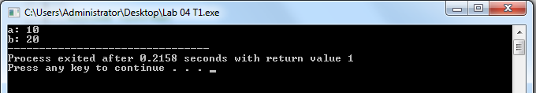

**Code#2 (Parameterized Constructors)**

#include <iostream>

using namespace std;

class Point

{

private:

int x, y;

public:

Point(int x1, int y1)

{

x = x1;

y = y1;

}

int getX()

{

return x;

}

int getY()

{

return y;

}

};

int main()

{

Point p1(10, 15);

cout << "p1.x = " << p1.getX() << ", p1.y = " << p1.getY();

return 0;

}

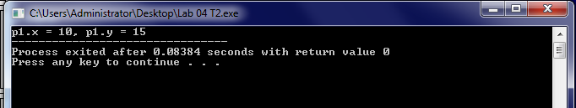

**Code#3 (Copy Constructor)**

#include<iostream>

#include<conio.h>

using namespace std;

class Example {

int a, b;

public:

Example(int x, int y) {

a = x;

b = y;

cout << "\nIm Constructor";

}

Example(const Example& obj) {

a = obj.a;

b = obj.b;

cout << "\nIm Copy Constructor";

}

void Display() {

cout << "\nValues :" << a << "\t" << b;

}

};

int main() {

Example Object(10, 20);

Example Object2(Object);

Example Object3 = Object;

Object.Display();

Object2.Display();

Object3.Display();

return 0;

}

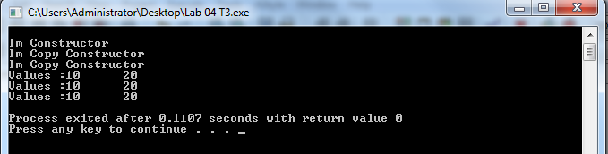

1. **Code#4 (Destructors)**

#include <iostream>

using namespace std;

class HelloWorld{

public:

HelloWorld(){

cout<<"Constructor is called"<<endl;

}

~HelloWorld(){

cout<<"Destructor is called"<<endl;

}

void display(){

cout<<"Hello World!"<<endl;

}

};

int main(){

HelloWorld obj;

obj.display();

return 0;

}

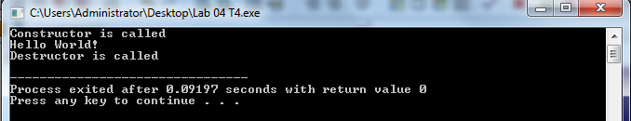

# Object Oriented Programing (CL-1004)

# Exercises

**Task_01:**

Create a C++ program to ask for a student’s ID, Name and Semester. The default values

of the student must be 0, “NaN” and 0 respectively. Ask for all the values atleast from 5

students and display all of them.

**Task_02:**

A class needs to be constructued, named as “RectShape”, it must have two variables

denoting the length and breadth of a rectangle and a function which calculates the

area of the rectanble (length x breadth). This class needs to have three constructors:

1 – A default constructor, with values of length and breadth set as zero.

2 – Two integer values as length and breadth

3 – A single integer value constructor containing both length and breadth.

You need to create objects of the said class and print the areas calculated by them.

**Task_03:**

Create a C++ program that requests a person's NIC number in order to register them

in a government housing scheme option. If no NIC number is provided, the message "The

person does not want the scheme" should be displayed. If the object is created, however,

a String stating "The person on the registered NIC has been included in the government

scheme" should be provided.

**Task_04:**

Using C++ you must use create constructors to implement the following processes as the

owner of Foodpanda (Make sure you put checks on wrong entries).

1. Guest Sign in using Email

2. Two choices

Booking a seat and ordering food

3. Determine the cost.

**Task_05:**

Create definitions for two iterations of a function that is overloaded. The first iteration of

this function, sum(), accepts an int array as an input and returns the sum of all its entries.

The second iteration of sum() accepts an int array and a character ('E' or 'O') as two

inputs. If the passed character is "E," it returns the array's sum of even items, and if it is "O,"

it returns the array's total of odd elements. It returns 0 for any other character (zero).

**Task_06:**

Consider the Task # 06 of OOP lab 3, you need to recreate the entire class but you have to use appropriate constructors in place of functions, use a default constructor or an empty constructor for the default value and use parameterized constructors for implementations of Civic and Rubicon. Implement the program by calling the specific constructors at compile time.

**Task_07:**

Create a class in C++ named as “TollCars”. Unsigned int is used to store the overall number of automobiles, while double is used to store the overall amount of money collected. Both of them are initialized to 0 through a default constructor. Another constructor increases the number of cars and increases the cash total by 0.50. Constructor number three must increase the car total but not increase the cash total. The two totals are finally shown by a member function named display().

A paying car should be counted by pressing one key, and a non-paying car should be counted by pressing a different key, according to the program. The application should print out the total number of automobiles and the total amount of money when the Esc key is pressed.